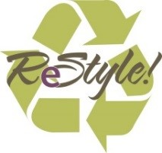

Thank you for your donation to ReStyle at Unity House!
It is the vision of ReStyle to provide rescued and donated items to individuals and families at a fair price in an environment that is professional and attractive. ReStyle serves as the site for retail skills training to staff and volunteers.
Unity House cannot Accept
Broken, stained, damaged items, or the following:

Wire and Plastic Hangers | Toys
Furniture | Car seats
Electronics | Used cosmetics/toiletries
Toasters, Coffee pots, Electric frying pans, Lamps | Used bras and underwear
Used Baby Furnishings | Used swimsuits
Medical Equipment | Decorations (holiday and other)
Vases and planters | Animal carrying crates and other animal accessories

Places that will accept the items that we cannot:
Household Items | Salvation Army (Latham & Albany) Goodwill (Hoosick Street)
Vases and planters | Call your local florist. They often love these donations.
Electronics | ERSI (Troy & Albany) @ (877) 280-7277 or Contact your local municipality to find when the next electronics recycling day is.
Furniture | HATAS (Albany)  Homeless & Travelers Aid Society (518)-612-2265  TAUM-Troy Area United Ministries: (518)-274-5920  Catholic Charities: (518)-453-6650

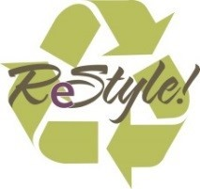
Unity House Donation Guideline Thank you for helping us to help others!
Restyle Accepts
Men’s, Women’s & children’s clothing | NEW toiletries
Shoes | Blankets
Handbags | Sheets
Jewelry | Towels
Books | Comforters
NEW socks/underwear | Curtains/draperies
Accessories-Belts, ties, etc.

ReStyle fosters the highest level of sustainability, respect and dignity to the community, providing gently used clothing to people in need and offering clothes for sale to discerning shoppers. Restyle is part of Unity House, a human services agency serving people in need since 1971. Due to a change in our distribution practices we can only accept brand new household items. We accept all clothing, sheets, towels, and blankets and other items on the list below. We distribute brand new household items like dishes, pots and pans, silverware to our consumers in different programs, through a new process. If you have items that are new in box or would like to purchase items to donate, please contact us at 518-274-2607 and ask for a Development Associate.

To assist us in meeting this commitment, please note the following:
- Merchandise should arrive laundered and free of stains and tears.
- Merchandise must be in-season:
Spring/Summer items accepted May 1st-August 15th
Fall/Winter items accepted October 1st-March 15th

Thank you for your support.

