

The program offers gifts for those receiving services through Unity House and other

[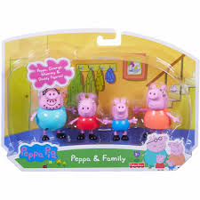](https://www.google.com/imgres?imgurl=http://i5.walmartimages.com/asr/c385f8c5-42de-4064-aac4-7e4dabdbd3e1_1.e2dbae78d8380609108802fe8fe5b588.jpeg&imgrefurl=http://www.walmart.com/ip/Fisher-Price-Peppa-Pig-Peppa-Family/36222452&docid=zQ7Fxe9yYZiHIM&tbnid=tUA97cvKXjUcUM:&w=2000&h=2000&bih=875&biw=1920&ved=0ahUKEwiXxbOsqYLOAhULXD4KHQfkDVIQMwieASgzMDM&iact=mrc&uact=8)children in need in our community.

Last year, through the generosity of many, over 1,300 children received gifts through Unity House.

See below for some suggestions for your community toy drive.

On behalf of those we serve, Thank You.

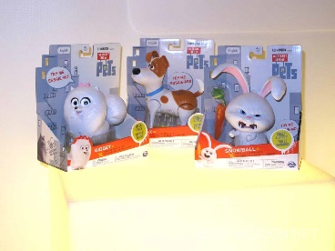

[](http://www.walmart.com/ip/Elizabeth-Arden-Celebrity-Fragrance-Favorites-Spray-Pens-Gift-Set-for-Women-3-Count/38695365)[](http://www.walmart.com/ip/Wilson-NFL-Super-Grip-Football/9906640)[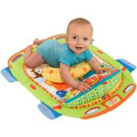](http://www.walmart.com/ip/Bright-Starts-Tummy-Cruiser-Prop-and-Play-Mat/22236462)

[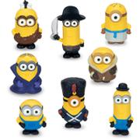](http://www.walmart.com/ip/Minions-8-Pack-Mini-Figure/43389833)

**ity UniOut of StocUnityskldjfklasjdf**

**[](http://www.target.com/p/e-l-f-cosmetic-set-medium-multi-color-42-oz/-/A-17445604#prodSlot=medium_1_2&term=cosmetic+sets)**[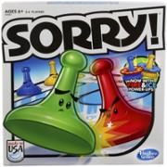](http://www.walmart.com/ip/Sorry-2013-Edition-Game/24806142)

[](http://www.walmart.com/ip/Summer-Infant-3-Stage-Booster-SuperSeat/28831347)[](http://www.walmart.com/ip/Dove-Men-Care-Extra-Fresh-Hygiene-Kit-3-pc/36125169)[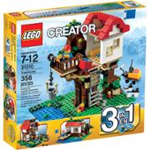](http://www.walmart.com/ip/LEGO-Creator-Treehouse-Play-Set/24501960)

[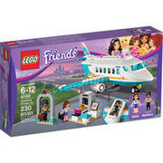](http://www.walmart.com/ip/LEGO-Friends-Heartlake-Private-Jet-41100/45791927)

[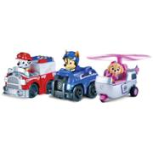](http://www.walmart.com/ip/Paw-Patrol-Racers-3-Pack-Vehicle-Set-Chase-Marshall-Skye/44678832)**[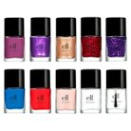](http://www.target.com/p/e-l-f-nail-set-10-pc/-/A-16194982#prodSlot=medium_1_1&term=nail+sets)**

[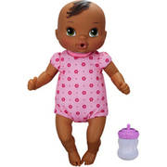](http://www.walmart.com/ip/Baby-Alive-Luv-n-Snuggle-Baby-African-American/45300874)[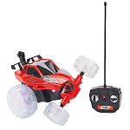](http://www.toysrus.com/buy/rc-cars/fast-lane-radio-control-x-treme-lightning-striker-vehicle-27-mhz-red-5f62041-32647566)[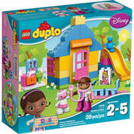](http://www.walmart.com/ip/LEGO-DUPLO-Doc-McStuffins-Doc-McStuffins-Backyard-Clinic-10606/45791924)[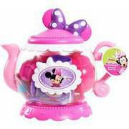](http://www.walmart.com/ip/Minnie-s-Bowtique-Teapot/45064636)[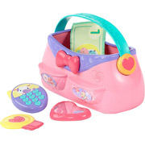](http://www.walmart.com/ip/Bright-Starts-Put-Take-Purse/16939751)[](http://www.walmart.com/ip/AXE-Apollo-Shower-Gel-Bodyspray-Invisible-Solid-Kit-3-pc/36032569)**[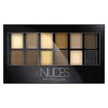](http://www.target.com/p/maybelline-expert-wear-eyeshadow-palette-0-34-oz/-/A-15568854#prodSlot=medium_1_4&term=eyeshadow+sets)**[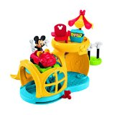](http://www.amazon.com/Fisher-Price-Fix-n-Fun-Garage/dp/B00IWQJ7YO/ref=sr_1_2?ie=UTF8&qid=1447701850&sr=8-2&keywords=toys+for+boys+mickey+mouse)

[](http://www.google.com/imgres?imgurl=http://kastorskorner.com/wp/wp-content/uploads/2013/09/TMNT_Classics_Wave_2__scaled_800.jpg&imgrefurl=http://kastorskorner.com/wp/2013/09/06/teenage-mutant-ninja-turtles-classics-officially-toys-exclusive/&h=877&w=800&tbnid=2wNvZxs48UtfFM:&docid=vuvK-NGnarvODM&ei=-C5KVvbtK8Tue5_ZmtgL&tbm=isch&ved=0CEIQMygQMBBqFQoTCPbJ6pnXlckCFUT3Hgodn6wGuw)

[](http://www.walmart.com/ip/Taylor-Swift-Wonderstruck-Enchanted-Gift-Set-for-Women-with-Bonus-Celebrity-Voice-Ring-Tone-3-pc/27653004)[](https://www.google.com/imgres?imgurl=http://thumbs.ebaystatic.com/images/g/X-gAAOSwjVVVwL70/s-l225.jpg&imgrefurl=http://www.ebay.com/sch/Spongebob-Squarepants-Doll-Toys/20919/bn_1890441/i.html&docid=oQdrlbgdS784MM&tbnid=rect7ZBApf20tM:&w=225&h=179&bih=875&biw=1920&ved=0ahUKEwiZ0pblqILOAhUBdz4KHR1OB18QMwjiAShhMGE&iact=mrc&uact=8)

[](http://www.toysrus.com/buy/rattles-teethers/bright-starts-take-n-shake-colors/styles-vary-8808-3618604)[](http://www.walmart.com/ip/Basic-Blue-Walmart-Gift-Card/43976460)**[](http://www.target.com/p/bullseye-box-gift-card/-/A-16671280#prodSlot=_1_3)**[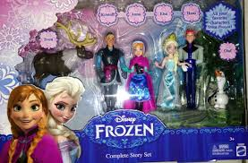](http://www.google.com/imgres?imgurl=http://images6.fanpop.com/image/photos/35500000/Frozen-Merchandise-frozen-35503900-1280-842.jpg&imgrefurl=http://www.fanpop.com/clubs/frozen/images/35503900/title/frozen-merchandise-photo&h=842&w=1280&tbnid=mNshykDJNZ3NRM:&zoom=1&docid=e50MzAQvc1QBKM&ei=06POU5mNMYeQyASekoLICQ&tbm=isch&ved=0CFwQMyggMCA&iact=rc&uact=3&dur=1825&page=2&start=18&ndsp=26)

[](http://www.toysrus.com/buy/fashion-dolls/monster-high-ghoulebrities-in-londoom-fashion-doll-3-pack-cgf51-43541066)[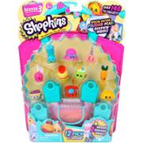](http://www.walmart.com/ip/Shopkins-Season-3-12-Pack/44706867)

**Unity House of Troy - 2431 6th Avenue - Troy, NY 12180**

**Phone: (518) 274-2607 - volunteer@unityhouseny.org**