



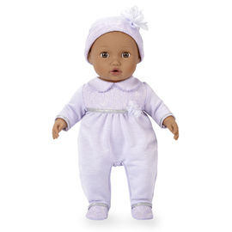On behalf of those we serve, Thank You!

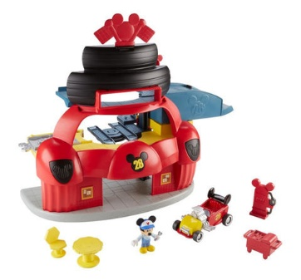**[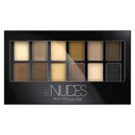](http://www.target.com/p/maybelline-expert-wear-eyeshadow-palette-0-34-oz/-/A-15568854#prodSlot=medium_1_4&term=eyeshadow+sets)**

[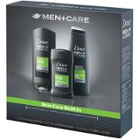](http://www.walmart.com/ip/Dove-Men-Care-Extra-Fresh-Hygiene-Kit-3-pc/36125169)

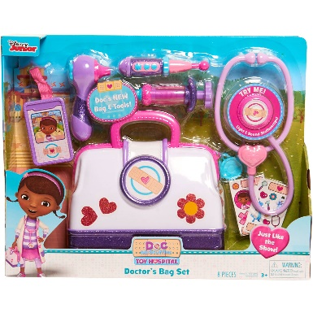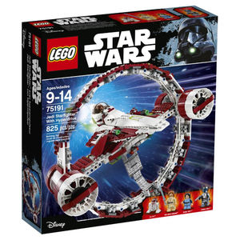[](http://www.walmart.com/ip/Paw-Patrol-Racers-3-Pack-Vehicle-Set-Chase-Marshall-Skye/44678832)**[](http://www.target.com/p/e-l-f-cosmetic-set-medium-multi-color-42-oz/-/A-17445604#prodSlot=medium_1_2&term=cosmetic+sets)**[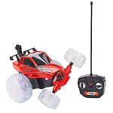](http://www.toysrus.com/buy/rc-cars/fast-lane-radio-control-x-treme-lightning-striker-vehicle-27-mhz-red-5f62041-32647566)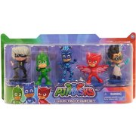[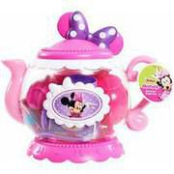](http://www.walmart.com/ip/Minnie-s-Bowtique-Teapot/45064636)